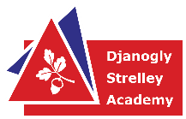


Djanogly Strelley Academy: EYFS 2YO Long Term Plan / Curriculum Overview

 | Autumn 1 | Autumn 2 | Spring 1 | Spring 2 | Summer 1 | Summer 2
Main theme | I wonder… How I am I Special  Who am I?  Who are my friends?  Who keeps me safe at nursery?  School routines | I wonder… who is in my family?  Family names  Different types of families  Who lives in my house? | I wonder… which is the best pet?  What are pets?  Pet names  Our own pets – sharing photos | I wonder… colours  Colour names  Matching Colours  Colour mixing  Rainbows | I wonder…Who lives on the Farm?  Animal names  Animal noises  Food from the farm  Growing beans | I wonder… which is the best way to travel?  Transport  Walking and cycling  Emergency vehicles
Experiences | Family Box | - Remembrance Day  - Children in Need  - Bonfire Night  - Diwali  - Christmas Party  - Christmas song Performance | - Animal Man?  - Lunar New Year  - Eid Al Fitr  - Mother’s Day activities | - Dress like your favourite colour day  - Pancake Day | - Father’s Day activities | - Dentist visit / role play  - People who help us Sports Day  - Eid al Adha
Books to explore  (Literacy) | 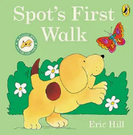  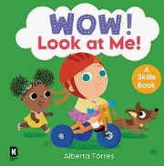  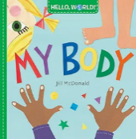 | 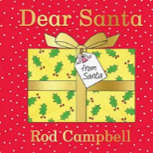  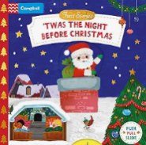  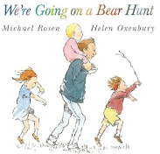 | 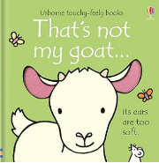  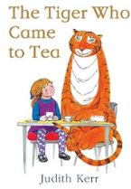  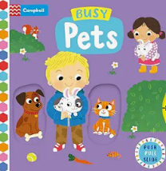 | 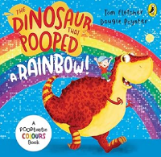  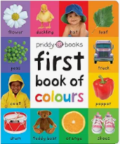  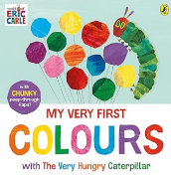 | 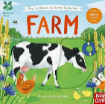  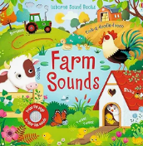  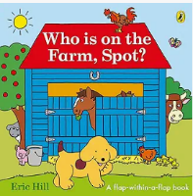 | 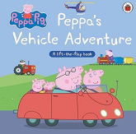  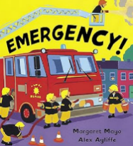  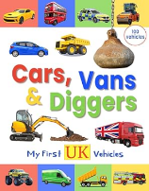
Phonics / Oracy | Focus Nursery Rhymes – What’s in the bag?  - Twinkle Twinkle Little Star  - Miss Molly had a  - Wind the Bobbin Up | Focus Nursery Rhymes – What’s in the bag?  - Incy Wincy Spider  - 3 Little Men in a Flying Sauce  - Hey Diddle Didddle  - Twinkle Twinkle | Focus Nursery Rhymes – What’s in the bag?  - The Grand Old Duke of York  - Miss Molly had a Dolly  - Hickory Dickory Dock  - 3 Little Monkeys  - Pat a cake | Focus Nursery Rhymes – What’s in the bag?  - 1,2,3,4,5  - Rainbow Song  - Jack and Jill  - Baa Baa Black Sheep | Focus Nursery Rhymes – What’s in the bag?  - Humpty Dumpty  - 5 Little Ducks  - Round and round the garden  - I’m a little teapot  - 5 Little Speckled Frogs | Focus Nursery Rhymes – What’s in the bag?  - Row, Row, Row your boat  - The wheels on the bus  - Down at the station  - Incy Wincy Spider  - 5 Little Men in a Flying Saucer  - 1,2,3,4,5  - Humpty Dumpty
Phonics / Oracy | Helicopter Stories | Helicopter Stories | Helicopter Stories | Helicopter Stories | Helicopter Stories | Helicopter Stories
Phonics / Oracy | Throughout the year in the 2YO unit, children will be encouraged to explore their oracy skills in telling and retelling stories, show and tell opportunities, expectations to talk in circle time activities for PSED, stem sentences in maths to promote oracy.
First 100 Words | The first 100 words will be introduced, used and modelled through quality interactions, story sessions and all adult-led learning.  Nouns: baby, daddy, mummy, man, woman, eyes, feet, hands, mouth, toes, tummy, bag, coat/jacket, dress, hat, pants, shoes/trainers, socks, trousers, ball, bike, bricks, bus, car, doll, duck, pram, swing, teddy bear, book, box, paper, pencil, bird, cat, dog, flower, tree, banana, apple, biscuit, plate, dinner, fork, knife, spoon, cup, drink, juice, water, milk.  Adjectives: Little, big, clean, dirty, hot, cold, dry, wet, up, down, in, on, through  Verbs: brush, clap, cook, mix, pour, cry, cut, brink, eat, hit, jump, kick, push, read, run, sit, sleep, stand, throw, catch, walk, wash, play, dress-up  Social words: Gone, bye-bye, look, more, hello, give, again, no, want, like
2YO Maths | Maths will be explored throughout the continuous provision, using tactile manipulatives to introduce counting, sorting, ordering and subitising. Children will be encouraged through quality interactions, to use appropriate mathematical vocabulary such as number names and language of size, weight and capacity.  Children will take part in number songs daily, using concrete resources to model the concepts of addition, subtraction, positional language and 1:1 correspondence.
2YO Maths | Mathematical Vocabulary  Number: one, two, three, more, less, how many? Same, different.  Size: big, small, tall, short, long  Weight: heavy, light  Capacity: full, light  Shape: square, triangle, circle. Rectangle, star  Positional language: up, down, under, in, on
PSED | Throughout the year in 2YO children will be supported in their Self-Regulation, Building Relationships and their Managing Self as part of their continuous provision and through quality interactions.
Physical Education 2YO’s | Throughout the year in the 2-year unit, children will access physical activities both indoors and outdoors, as part of their continuous provision to allow them to explore being active within their own interests, this covers both fine and gross motor movement skills
UTW | Throughout the year in 2YO children will learn about the Past and Present, People, Culture and Communities and The Natural World as part of their continuous provision and taught directly through quality interactions, ‘What’s in the Bag’ and Stories.
EAD / music | Throughout the year in 2YO children will access creative activities as part of their continuous provision to allow them to explore and create within their own interests

