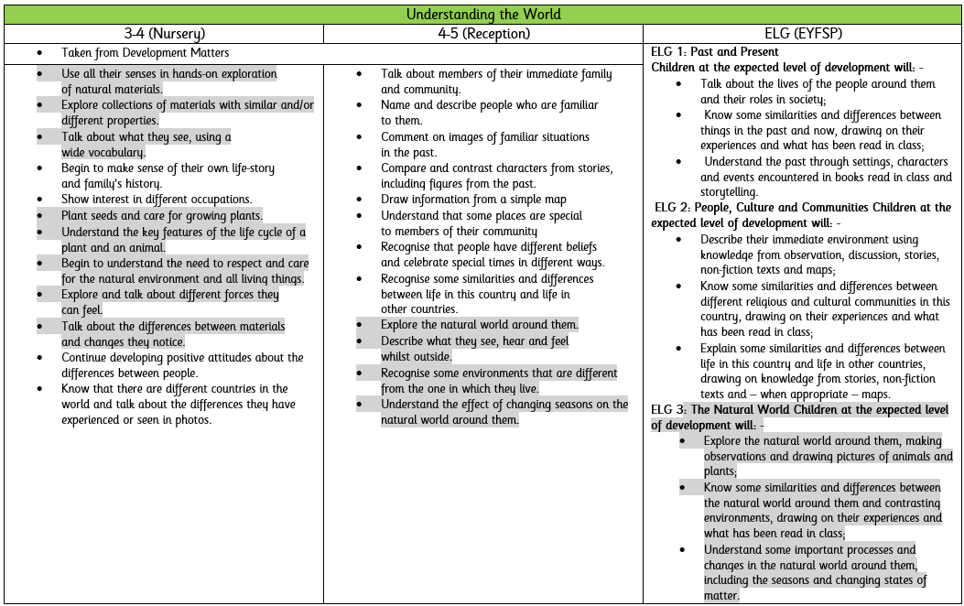

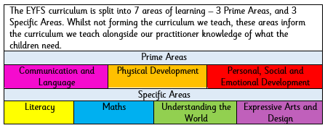
https://primarysite-prod.s3.amazonaws.com/theme/SeagravePrimary/school-logo.png
The EYFS curriculum and learning areas differ to those of the National Curriculum and learning is not taught explicitly under NC subject headings however, all of these subjects are explored extensively both through our continuous provision and through teacher-led input. There is much crossover of NC subjects in different areas of the EYFS Learning areas.
Much of Science comes under the Learning Area of Understanding the World
At the end of the EYFS, children are assessed in 17 Early Learning Goals (ELG’s). The ELGs should not be used as a curriculum or in any way to limit the wide variety of rich experiences that are crucial to child development, from being read to frequently to playing with friends. The ELGs should support teachers to make a holistic, best-fit judgement about a child’s development, and their readiness for year 1. When forming a judgement about whether an individual child is at the expected level of development, teachers should draw on their knowledge of the child and their own expert professional judgement. This is sufficient evidence to assess a child’s individual level of development in relation to each of the ELGs. Sources of written or photographic evidence are not required, and teachers are not required to record evidence.

The EYFS learning and development requirements comprise of:
• The seven areas of learning and development and the educational programmes
• The early learning goals, which summarise the knowledge, skills and understanding that all young children should have gained by the end of the reception year
• The assessment requirements (when and how practitioners must assess children’s achievements, and when and how they should discuss children’s progress with parents and/or carers) In our school, the statutory assessment comes at the end of the Reception Year in the form of the Early Years Foundation Stage Profile (EYFSP).

What Subject Leaders need to know about EYFS: Science

