


Djanogly Strelley Academy: EYFS F1 Long Term Plan / Curriculum Overview

 |  |  | Autumn 1 | Autumn 2 |  | Spring 1 |  | Spring 2 |  |  | Summer 1 |  | Summer 2
Main theme |  |  | I wonder… How I am the same and different?  starting nursery /new beginnings, rules and routines, all about me, families, homes, feelings and emotions.  Introduce Zones of Regulation | I wonder… what is a celebration?  Diversity  How we celebrate, what celebrations we all take part in, what celebrations do some of us take part in but not all, how do we celebrate the same things differently  Seasonal changes – autumn (beginning) and winter (end) |  | I wonder… would a lion make a good pet?  Different types of animals / classifications  Habitats and environments  Care and responsibility  Our pets |  | I wonder… How many people have helped me today? |  |  | I wonder… How does the world change?  Growing  Where our food comes from |  | I wonder… How can I keep myself safe and healthy?
Experiences |  |  | Family Box | Remembrance Day  Christmas song Performance |  | Animal Man? |  | Walk to Asda/ visiting profession  People who help us- fire engines |  |  | Growing beans  Butterflies  Tadpoles/frogs |  | Dentist visit / role play  Sports day
Books to explore  (Literacy) |  |  | 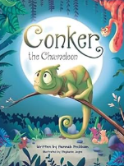  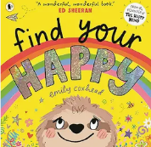  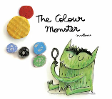 | 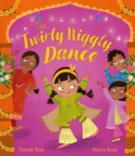  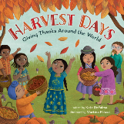 |  | 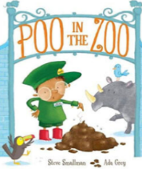  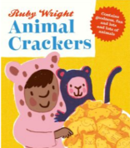  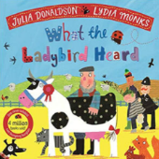 |  | 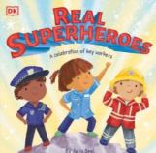  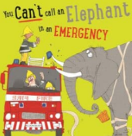  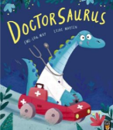 |  |  | 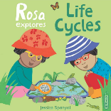  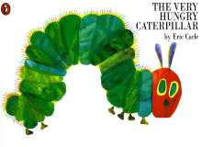  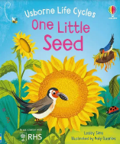 |  | 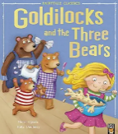  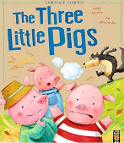  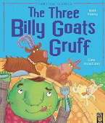
 | Oracy | Poetry Basket:  - Chop Chop  - Cup of Tea  - Pointy Hat  - Leaves are Falling  - Falling Apples  - Wise Old Owl  - 5 Little Pumpkins |  |  | Poetry Basket:  - Breezy Weather  - Shoes  - Basket of Apples  - Mice  - A Chubby Little Snowman  - Christmas Time  - Christmas Star |  | Poetry Basket:  - I Can build a snowman  - A Little House  - Let’s put on our mittens  - Furry Furry Squirrel  - Hungry Birdies  - Popcorn! |  | Poetry Basket:  - Pancakes by Christina Rosetti  - Stepping Stones  - Mrs Bluebird  - Leaves are Green  - A Little Seed  - Spring Wind | Poetry Basket:  - Under a Stone  - Monkey Babies  - Pitter Patter  - Sliced Bread  - A Little Shell |  | Poetry Basket:  - 5 Little Peas  - The Fox  - Dance  - Thunderstorm  - 5 Little Owls  - If I were so small
 | Oracy | Helicopter Stories |  |  | Helicopter Stories |  | Helicopter Stories |  | Helicopter Stories | Helicopter Stories |  | Helicopter Stories
 | Oracy | Throughout the year in F1 children will be encouraged to explore their oracy skills in telling and retelling stories, show and tell opportunities, expectations to talk in circle time activities for PSED, stem sentences in maths to promote oracy.
Nursery phonics |  |  | Rhyme Time  Whole Class | Rhyme Time  Whole Class  N2 Sound Groups:  S a t p I n m |  | Rhyme Time  Whole Class  N2 Sound Groups:  d g o c k e |  | Rhyme Time  Whole Class  N2 Sound Groups:  u r h b f l |  |  | Rhyme Time  Whole Class  N2 Sound Groups:  j v w y z qu ch |  | Rhyme Time  Whole Class  N2 Sound Groups:  ck x sh th ng nk
Rhyming Text (Termly for phonics) |  |  | 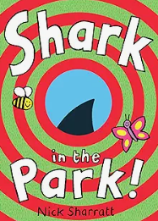 | 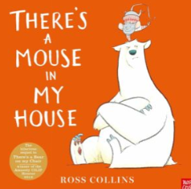 |  | 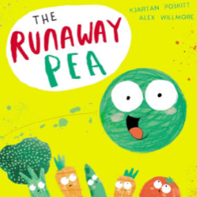 |  | 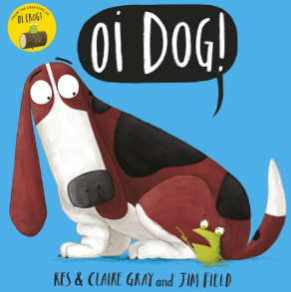 |  |  | 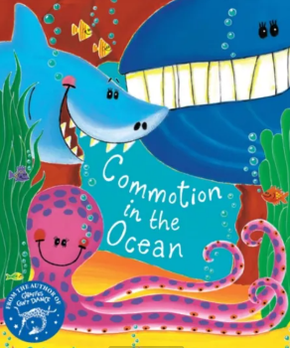 |  | 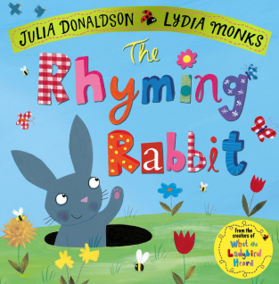
Writing and Fine Motor |  |  | Dough Disco | Dough Disco  Guided Drawing  Stage 1: Circles and spirals  - To form circles and spirals correctly  - To introduce the vocabulary of pre-writing patterns   |  | Dough Disco  Guided Drawing  Stage 2: Lines and diagonals  - To form lines and diagonals pre-writing patterns correctly.  - To introduce the vocabulary to describe pre-writing patterns.   |  | Dough Disco  Guided Drawing  Stage 2: Lines and diagonals  - To form lines and diagonals pre-writing patterns correctly.  - To introduce the vocabulary to describe pre-writing patterns.   |  |  | Dough Disco  Guided Drawing  Stage 3: Jellies and zigzags  - To form jellies and diagonals  - To introduce the vocabulary to describe jellies and zig-zags     |  | Dough Disco  Guided Drawing  Stage 3: Loopies and waves  - To form jellies and diagonals  - To introduce the vocabulary to describe jellies and zig-zags    
Nursery Maths |  |  | - Counting Songs  - More Than, Fewer and the Same  - Explore and Build with shapes | - Pattern 1  - 1:1 Correspondence  - Hear and say number names  - I hear 1,2,3 |  | - Begin to order number names  - Join in with repeats  - Explore position and space  - Show me 1,2,3  - Take and give 123 |  | - Move and label 123  - Explore position and repeats  - Explore own first patterns  - Compare and sort collections  - Talk about dots |  |  | - Start to puzzle  - Making patterns together  - Show me 5  - Make games and actions  - 5 frames |  | - Stop at 12345  - My own pattern  - 10 frames
PSED |  |  | Ready, respectful, safe  Understanding our rules  How to be a good school citizen (expectations, people in school who help us, friendships)  Zones of regulation (linked to Colour Monster) | Being inclusive of others  Different cultures and religions |  | Caring for others |  | People who help us  Careers  Future aspirations |  |  | Looking after our environment |  | Eating well / dental hygiene  Physical health, changes to our bodies, moving on and new transitions  Transition – Reception transition for N2’s ready.  Keeping safe when we are outdoors – as and when with weather
Physical Education F1 |  |  | Throughout the year in F1 children will access physical activities as part of their continuous provision to allow them to explore being active within their own interests, this covers both fine and gross motor movement skills
UTW |  |  | Throughout the year in F1 children will learn about the world through their interests in both the continuous provision and as part of the book-led learning topics.
EAD |  |  | Throughout the year in F1 children will access creative activities as part of their continuous provision to allow them to explore and create within their own interests

