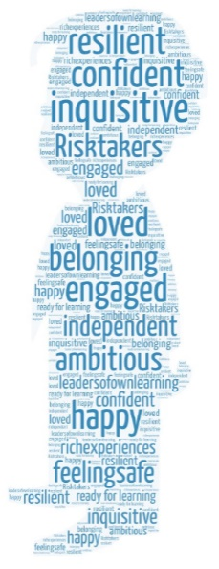
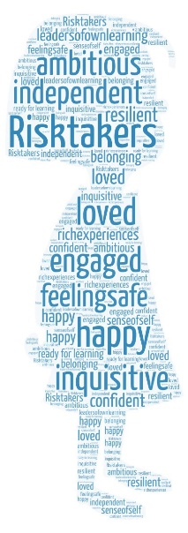
We believe that every early year’s child is unique and has the right to learn through play.
We provide a rich and enabling environment, where children feel they belong, are understood, and are inspired to succeed.
We know that this requires skilful interactions by knowledgeable adults to build the foundations for life.

The Foundation Stage is where children begin their school life and where they are supported to become happy, confident and independent learners. The curriculum within the Early Years is planned around 4 main principles which underpin everything that we do.

A Unique Child | Positive Relationships | Enabling Environments | Learning and Development
Every child is a competent learner from birth who can be resilient, capable, confident and self-assured. | Children learn to be strong and independent from a base of loving and secure relationships with parents and/or a key person | The environment plays a key role in supporting and extending children’s development and learning | Children develop and learn in different ways and at different rates and all areas of Learning and Development are equally important and interconnected

Our children learn skills, acquire new knowledge and demonstrate their understanding through 7 areas of learning and development. These are split in to prime and specific areas:
Prime areas
- Communication and Language
- Physical Development
- Personal, Social and Emotional Development
Specific areas
- Literacy
- Mathematics
- Understanding the World
- Expressive Art and Design

In Nursery we focus on the Prime Areas of learning and then move on to the other areas once they start in the Reception Classes.

As well as these the curriculum also develops the 3 characteristics of effective learning. These are
- Playing and Exploring
- Active Learning
- Creating and Thinking Critically
At Djanogly Strelley Academy we deliver our curriculum through planned, purposeful play as well as direct whole class and small group teaching activities. This is planned to meet the needs of the children and linked to their interests. Learning takes place both inside and outside using the environment and a variety of open ended resources. Children will take their learning and play to different levels to suit their interests and will develop new skills and wider knowledge to challenge themselves.

How we teach our curriculum

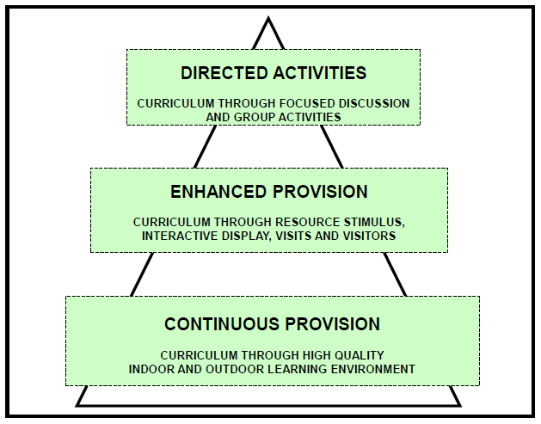

Progress is closely monitored by all early years staff and is evidenced in a range of ways; through our interactions with children, photographs, children’s work and focused assessment sheets.

At the end of the foundation stage an EYFS profile will be completed for each child and shared with their parents/carers. An EYFS Profile is a legal document that enables year 1 teachers to plan an effective, responsive and appropriate curriculum that will continue to meet all children’s needs after they leave the Foundation Stage.

